One Rule  One Mechanic  One Interpretation  The SFOA is the second largest football association in Oregon. Our area includes Colton and Mill City to the east, Scio and Monmouth-Independence to the south, Willamina and Sheridan to the west, Yamhill-Carlton and Newberg to the north, and all the other schools in between.  All Oregon high school football officials and associations are certified and regulated by the state governing body known as Oregon School Activities Association (OSAA). SFOA is one of the 14 football associations in Oregon and its entire membership are all members of the Oregon Athletic Officials Association (OAOA).  www.osaa.org  www.oreofficials.org  ww |  |  | Ken Woods, Commissioner Salem Football Officials Association  PO Box 2842  Salem OR 97308 |  | Salem Football Officials Association  - A brief description or your company tagline would work well here  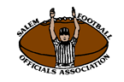  CONTACT SFOA  Ken Woods, Commissioner Salem Football Officials Association PO Box 2842 Salem OR 97308  commissioner@salemfbrefs.org  503-871-0056  www.salemfbrefs.org

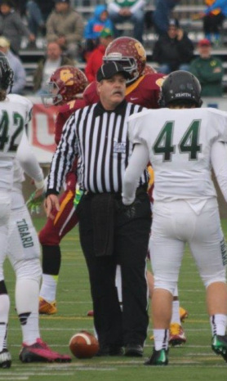  Officials Code of Ethics  Officials at interscholastic athletic events are participants in the educational development of high school students. As such, they must exercise a high level of self-discipline, independence and responsibility. The purpose of this Code is to establish guidelines for ethical standards of conduct for all interscholastic officials. Officials shall master both the rules of the game and the mechanics necessary to enforce the rules, and shall exercise authority in an impartial, firm and controlled manner.  Officials shall work with each other and their state associations in a constructive and cooperative manner. Officials shall uphold the honor and dignity of the profession in all interaction with student-athletes, coaches, athletic directors, school administrators, colleagues, and the public.  O  Customize in Almost No Time  Think a document that looks this good has to be difficult to format? Think again! To easily apply any text formatting you see in this document with just a tap, on the Home tab of the ribbon, check out Styles. | Make the Right Call!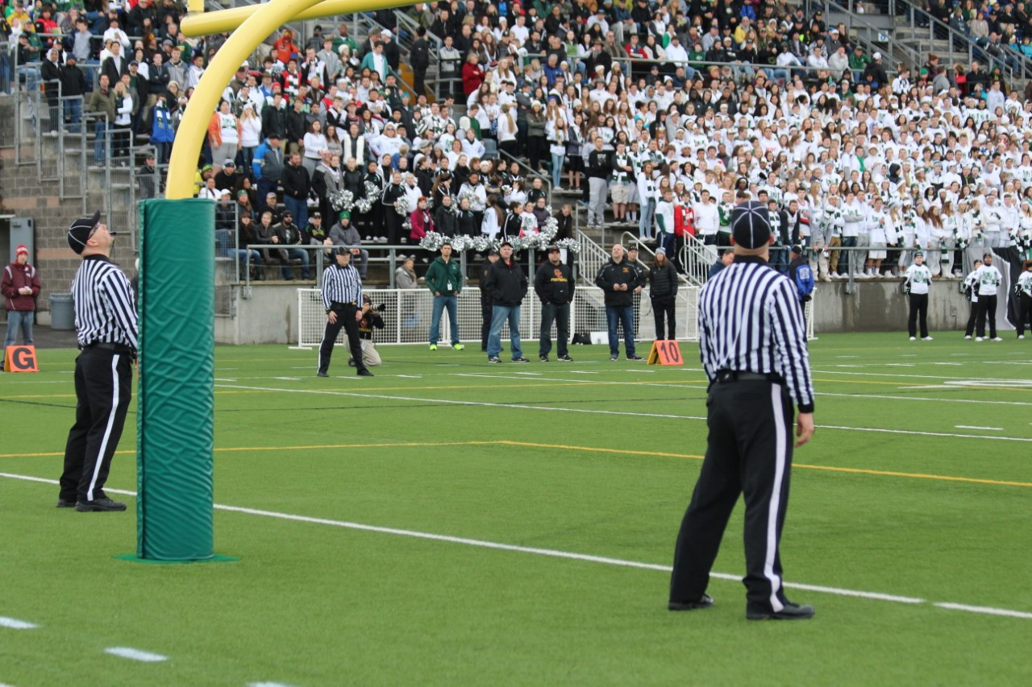  Officials shall prepare themselves both physically and mentally, shall dress neatly and appropriately, and shall comport themselves in a manner consistent with the high standards of the profession. Officials shall be punctual and professional in the fulfillment of all contractual obligations. Officials shall remain mindful that their conduct influences the respect that student-athletes, coaches and the public hold for the profession  Officials shall, while enforcing the rules of the play, remain aware of the inherent risk of injury that competition poses to student-athletes. Where appropriate, they shall inform event management of conditions or situations that appear unreasonably hazardous. Officials shall take reasonable steps to educate themselves in the recognition of emergency conditions that might arise during the course of competition.  Focus on What You Do Best  You might try a summary of competitive benefits at left and a brief client success story or some of those glowing testimonials here in the middle.  The right side of this page is perfect for a summary of key products or services. |  | Do any of following factors entice you to become a football official?  - The love of the game…  - Potential of additional income…  - Physical fitness opportunities…  - Face new challenges and to grow…  - Flexible schedule/availability of games…  - A chance to make numerous new friends…  Interested in becoming a football official?  Becoming an official allows you to participate in sports activities, as well as providing a valuable service to your community. If you are interested, please contact us for details on how to become an official.  SFOA Service Area  SFOA services 34 high schools (77 teams), 33 middle schools (54 teams), and 46 youth football teams in the Salem Mid-Willamette Valley area.

